Lighting analysis

30034301 Ambrose Collins

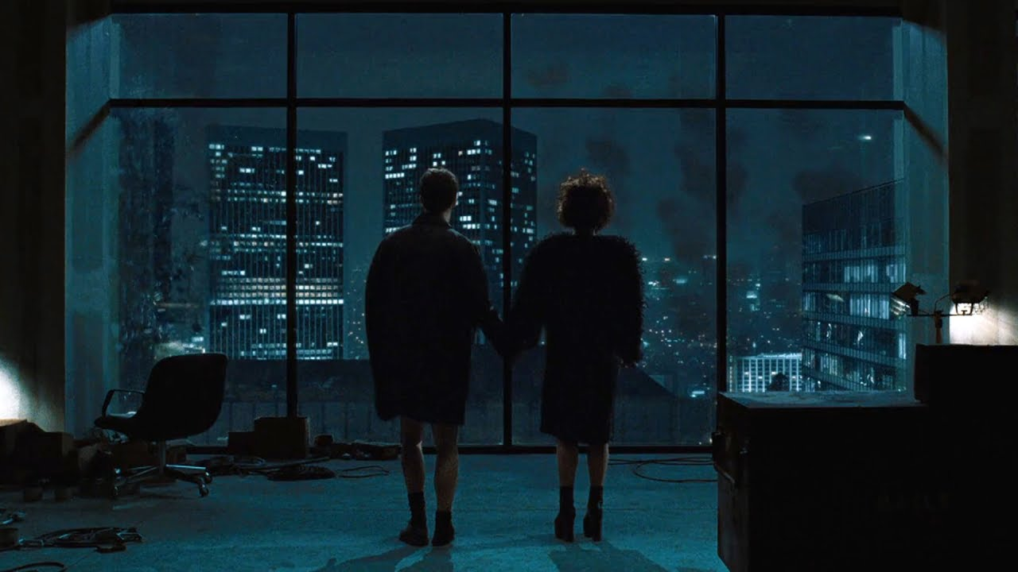/fight club/
This image uses low key lighting as well as side lighting, also frontal lighting to make a very low light scene visible it achieves this by having small lights such as the lamps to the side and the buildings off in the distance hard lighting is also an effect here it really makes the shadows pop and have contrast, and the figures stand out and I think this type of lighting was chosen deliberately to show all those examples.
The image is cold lighting and achieves this effect again by using small lighting. The depth in this image is also very noticeable given how the buildings in the back give off a sense of distance and the power of the lights also give off this effect too. The lights mixed in with the darkness of night creates a cool blue hue around the scene. The light is of course artificial given how the lights are clearly made from technology such as lamps and buildings lights, the tone of this scene is quiet and atmospheric it sets a mood that mood being space there’s a ton of space in this image the vastness of the sky and the far away buildings really make this image stand out especially because of the use of lights as before mentioned it really shows how lights and the size of them can effect the final product.

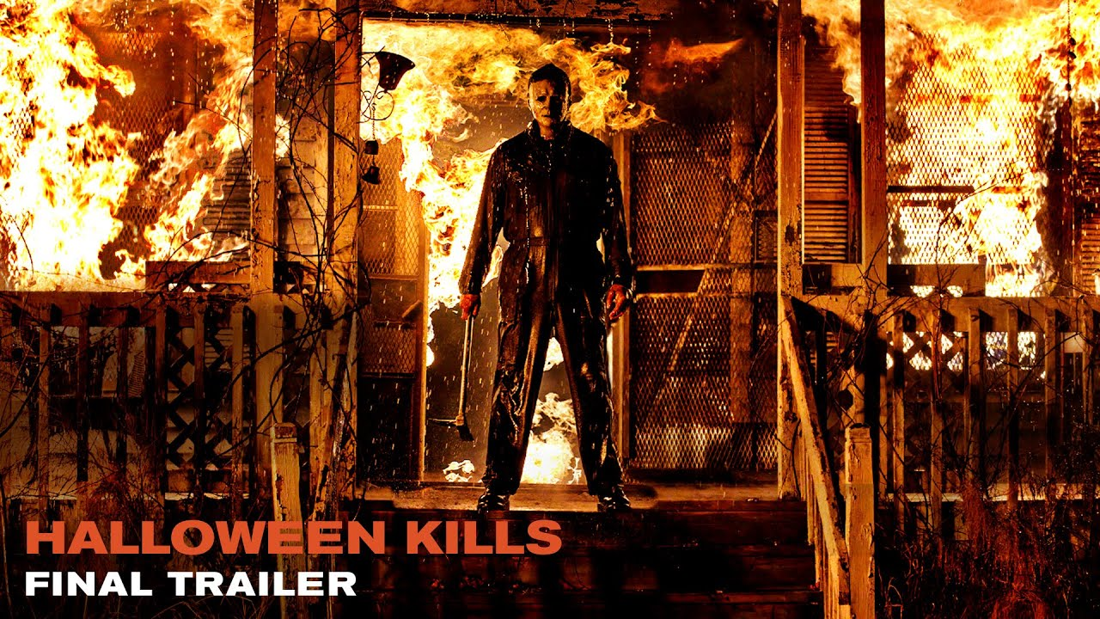
/Halloween kills/
The complete opposite in terms of lighting compared to the other image this one doesn’t use its light scarcely at all in fact it’s pretty much everywhere the key lighting is definitely the flames in this image its also warm lighting given the orange hue everywhere pretty fitting since this is a Halloween movie and the lighting definitely compliments that. The lighting is natural since it is fire and not any technology this sets a mood mainly killer intent since the fire is everywhere its really cool and the person in charge of lighting used the lighting effectively in this scene. Since the fires everywhere pretty much everything has a shadow especially things up in front and again it looks radical. The depth in this image isn’t as noticeable or as great as the fight club image but non the less its still there Michael Myers being in the fore front of the image the flames are in the background although some flames also pop out in front which gives off a really cool effect. This image also has a very hard light again like I mentioned before there are shadows practically everywhere as well as the fire, it also draws attention to the centre piece Michael Myers using both shadows and flames to achieve this. The image is the complete opposite of diffused light there’s nothing here diffusing the lighting so much so you can see all of Michael Myers body everything is lit up besides a few shadows creating texture.
It also has contrast for example the fire is super bright but that makes the dark parts stand out more creating a cool looking contrast in the scene.
The lighting is coming from the back so its back lighting creating an outline of Michael and making him stand out even more

Conclusion comparison
The first image is darkly lit and cold while in comparison the second one is bright and warm in fact both images are opposites in a lot of ways such as one uses natural lighting such as fire and the other one uses artificial lamps and buildings to light up the scene its also opposite in the way there are more people in the first image and less in the second one the first is soft lighting and the second is hard see what I mean by complete opposites

